

**California State University, East Bay**

**Business Analytic MS**

THE HISTORY OF

SAN FRANCISCO BUSINESS

Spring 2020

Advisor

Dr. Jiming Wu

Submitted By:

Ayushi Shrivastava – tf2272

Shubhangi Jain – qt9379

**INTRODUCTION**

In the ever-growing and ever-expanding business market, there is an urgent need to quantitatively evaluate and measure the effect of various data characteristics relating to business processes, revenue, finance, and their interdependence. Demand and supply are the main elements in the most general economic sense that determine the survival of the market.

Many factors drive a company's growth, such as goods sold, business position, tax scheme, ownership, consumer adaptation, and business deals. The dataset, Registered Business Locations-San Francisco, was obtained from the data.sfgov.org website, which is an electronic archive for data sets related to San Francisco City and County, gathered from various agencies such as Public Works, Real Estate, Social Services, and several others.

This research was performed to see which new industries have arisen over time in the region of San Francisco, and which of these industries has the potential for maximum growth. The dataset has business data consisting of 26 attributes and 216,650 values for businesses located in the San Francisco Bay Area from the year 1891-2017. Each registered business may have multiple locations and each location is a single row.

**RESEARCH METHODOLOGY**

This project aims to examine the database of companies in San Francisco. In this database we have numerous companies established from the year 1891 to 2017 in the heart of the bay area. The outcome of any business is either its success or failure. On similar grounds, the dataset consists of many businesses that have experienced tremendous growth and on the other hand, it also consists of business who had to experience unfortunate closure.

Before proceeding with any kind of analysis, we performed many cleaning procedures on the collected data to make it usable. Various python packages were used to process the analysis like folium package to visualize maps, sklearn packages to learn machine learning models, etc. The data visualization helped us to understand the emerging businesses and trends. To understand the impact of adding new businesses in each category, we formulated a hypothesis and directed our analysis around it to reach a finding. There is a wide scope of this project and can be examined furthermore to find new insights.

**DATA DESCRIPTION**

The dataset has business data consisting of 26 attributes and 216,650 values for businesses located in the San Francisco Bay Area from the year 1891-2017. The column description is as follows:

|  |  |
| --- | --- |
| ***Field Name*** | ***Description*** |
| **Location ID** | Location Identification Number. Each DBA has a unique LIN for location-specific tax filings |
| **Business Account Number** | A seven-digit number assigned to registered business accounts |
| **Ownership Name** | Business owner(s) name |
| **DBA Name** | Doing Business As Name or Location Name |
| **Street Address** | Business location street address |
| **City** | Business location city |
| **State** | Business location state |
| **Source Zipcode** | Business location zip code |
| **Business Start Date** | Start date of the business |
| **Business End Date** | The end date of the business |
| **Location Start Date** | Start date at the location |
| **Location End Date** | End date at the location |
| **Mail Address** | Address for mailing |
| **Mail City** | Mailing address city |
| **Mail State** | Mailing address state |
| **Mail Zipcode** | Mailing address zip code |
| **NAICS Code** | The North American Industry Classification System (NAICS) is a standard used by Federal statistical agencies to collect, analyze, and publishing statistical data related to the U.S. business economy. A subset of these are options on the business registration form used in the administration of the City and County's tax code. The registrant indicates the business activity on the City and County's tax registration forms. If multiple, separated by spaces |
| **NAICS Code Description** | The NAICS code description (multiple if there are multiple codes indicated for the business) |
| **Parking Tax** | Whether or not this business pays the parking tax |
| **Transient Occupancy Tax** | Whether or not this business pays the transient occupancy tax |
| **LIC Code** | The LIC code of the business, if multiple, separated by spaces |
| **LIC Code Description** | The LIC code description ("multiple" if there are multiple codes for a business) |
| **Supervisor District** | The Supervisor District in which the business location falls. Not applicable outside of San Francisco |
| **Neighborhoods - Analysis Boundaries** | The Analysis Neighborhood in which the business location falls. Not applicable outside of San Francisco |
| **Business Corridor** | The Business Corridor in which the business location falls if it is in one. Not all business locations are in a corridor |
| **Business Location** | The latitude and longitude of the business location for mapping purposes |

**DATA CLEANING**

**Step 1:** The first problem in the dataset is the different spellings used of the same city (San Francisco). We just use another dataset containing San Francisco zip codes to compare the SF Company Dataset to extract all San Francisco businesses without the hassle of string search.

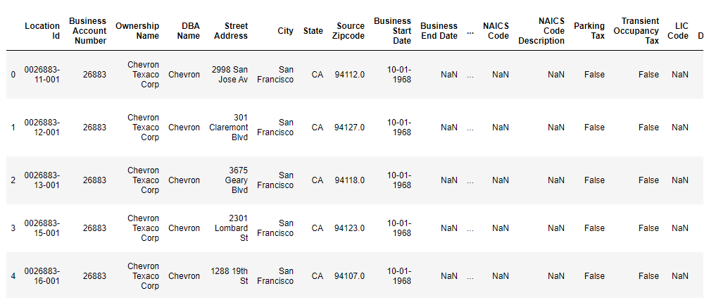

**Step 2:** To fetch active businesses, we will aim at those businesses which don’t have end dates. To achieve this, we evaluated all the null values of businesses from the dataset by filtering the dates which have no end date to fetch a data frame of only active businesses. So, we can identify the high concentration of businesses specifically pockets of San Francisco. **There are a total of 172670 active businesses in the dataset.**



**Step 3:** After we infer the businesses having no end date, we are assured that they are still active and have not shut down. We are more focused on the number of active businesses in San Francisco, therefore, we compared the two datasets having active businesses and another containing zip codes of San Francisco city. **There is a total of 135031 active business in San Francisco**.

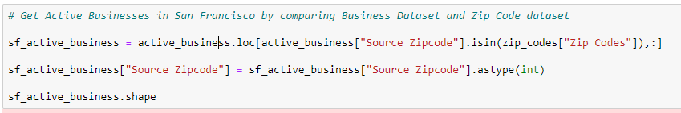

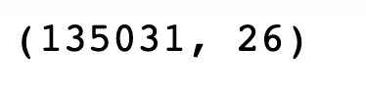

**Step 4:** We need to remove businesses whose business location is not specified. Below is the number of businesses with no business location specified.

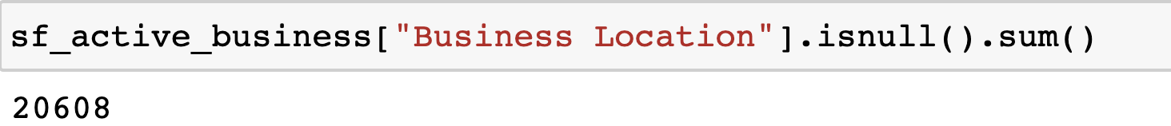

**Step 5:** As the data frame has numerous inconsistencies, we can see that only a minor bit of business doesn’t have a location determined. Along these lines, we separate map coordinates from `the 'Business Location' attribute with the goal that we can utilize it to plot on the map. For extraction of latitudes and longitudes, to get just the desired coordinates, we will use a regular expression to split the address. After acquiring the coordinates, we make another data frame with no null values.

**DATA IMPLEMENTATION**

**HYPOTHESIS FORMULATION**

***Null Hypothesis:*** More businesses lead to more rivalry and favoritism in each business group, gradually reducing the number of active businesses.

***Alternate Hypothesis:*** More businesses in each category generate greater demand for similar services, thus increasing the number of active businesses.

After cleaning the dataset, we need to find the number of Business with accurate Longitude and Latitude.

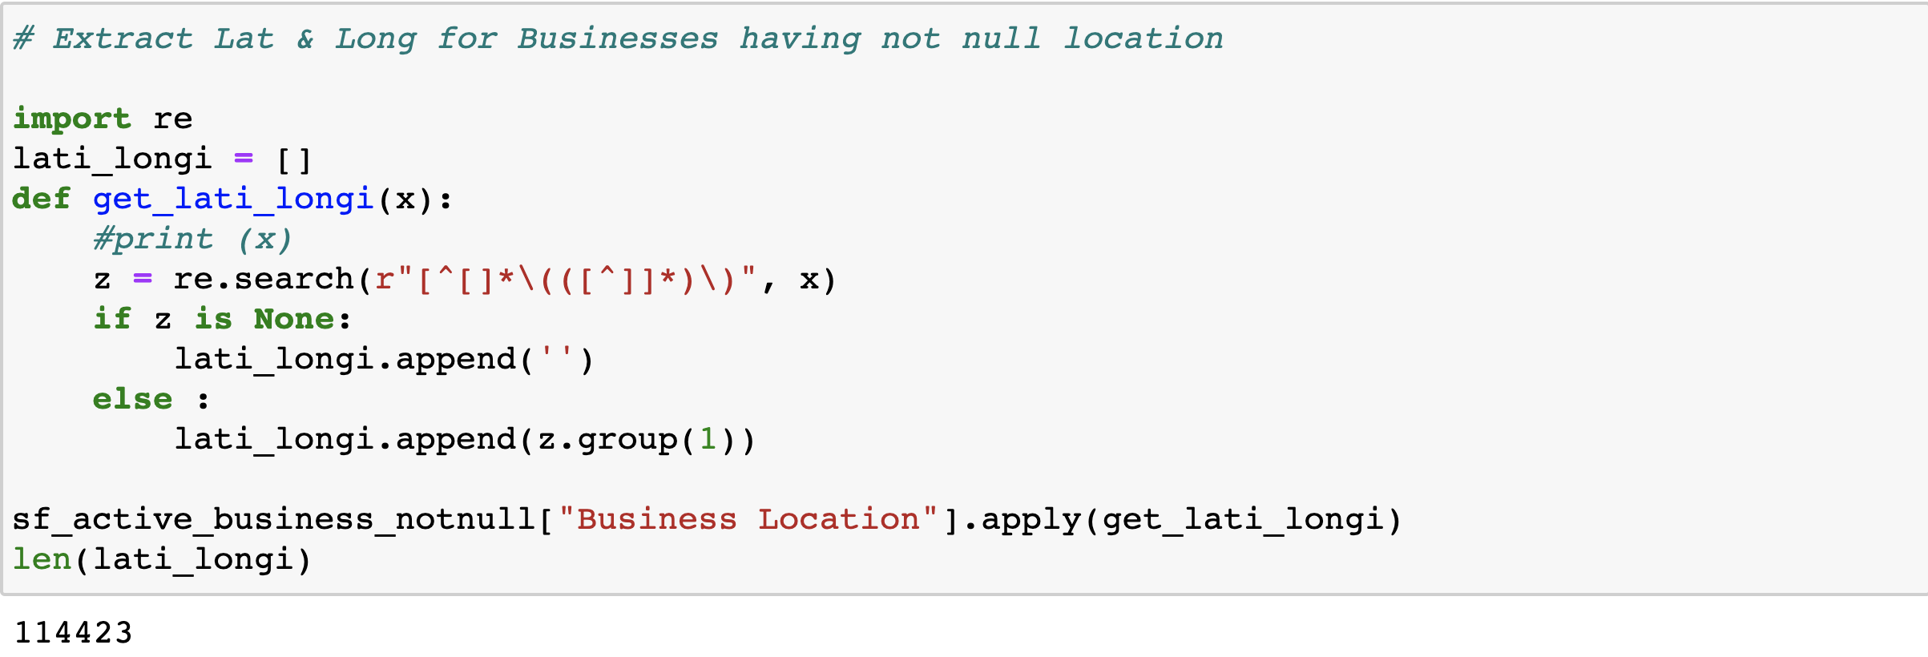

**Adding a new coordinates column for latitude and longitude**

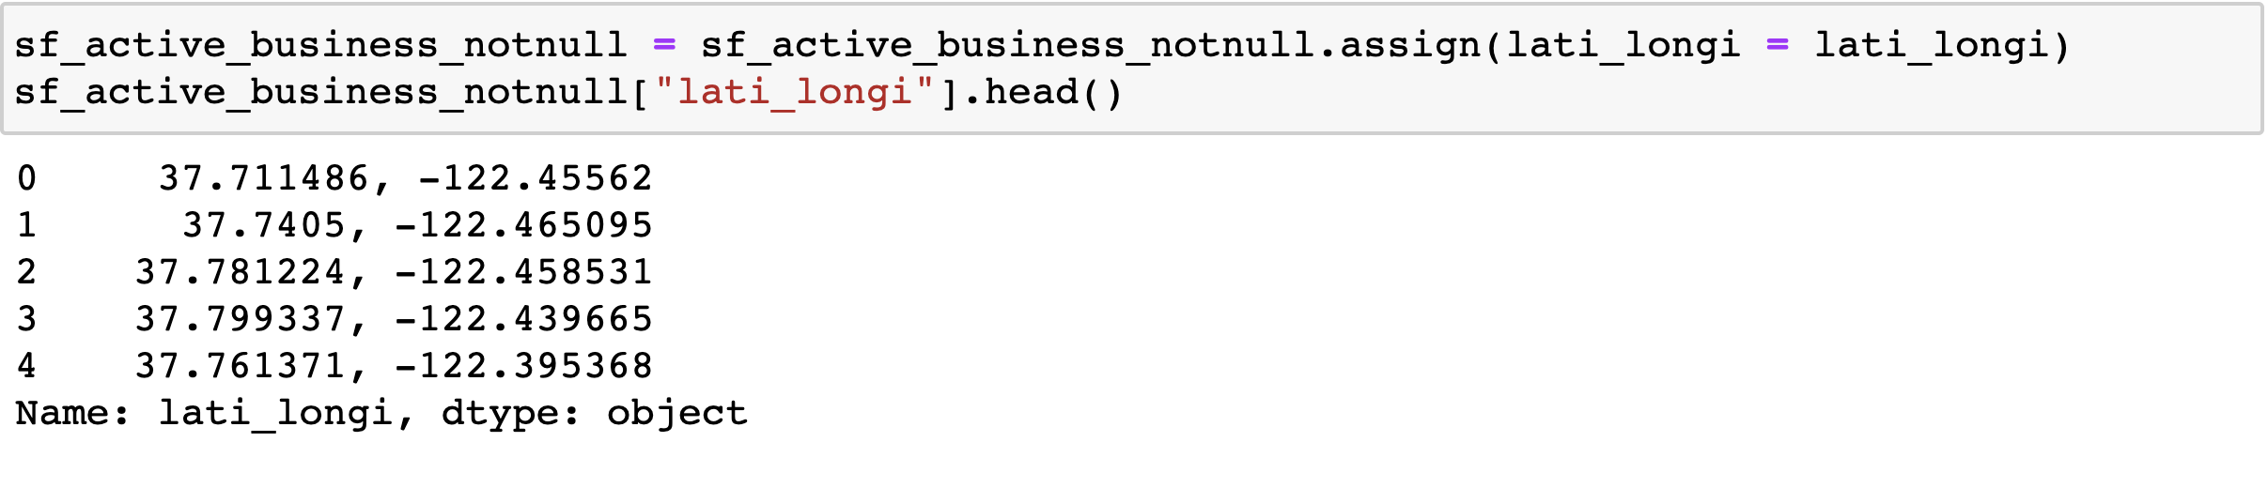

**Created a separate data frame for latitude and longitude having no null values**

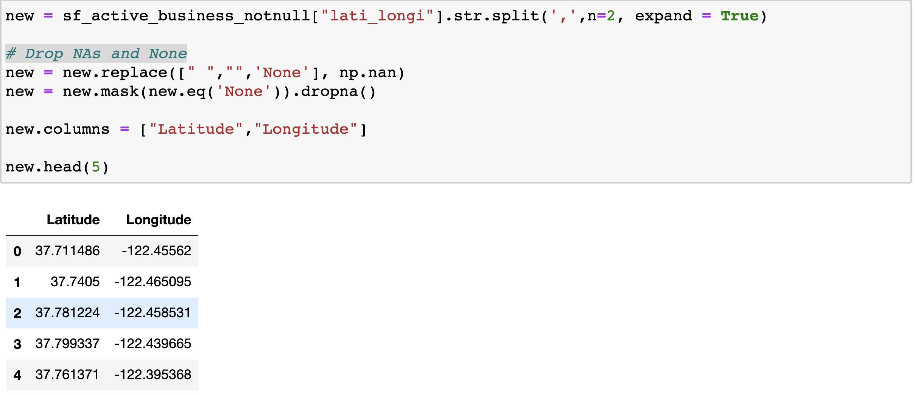

It is important to know the count of business within each zip code to plot the number of businesses by zip code to get an estimate of the difference in the quantity of business across each zip code.

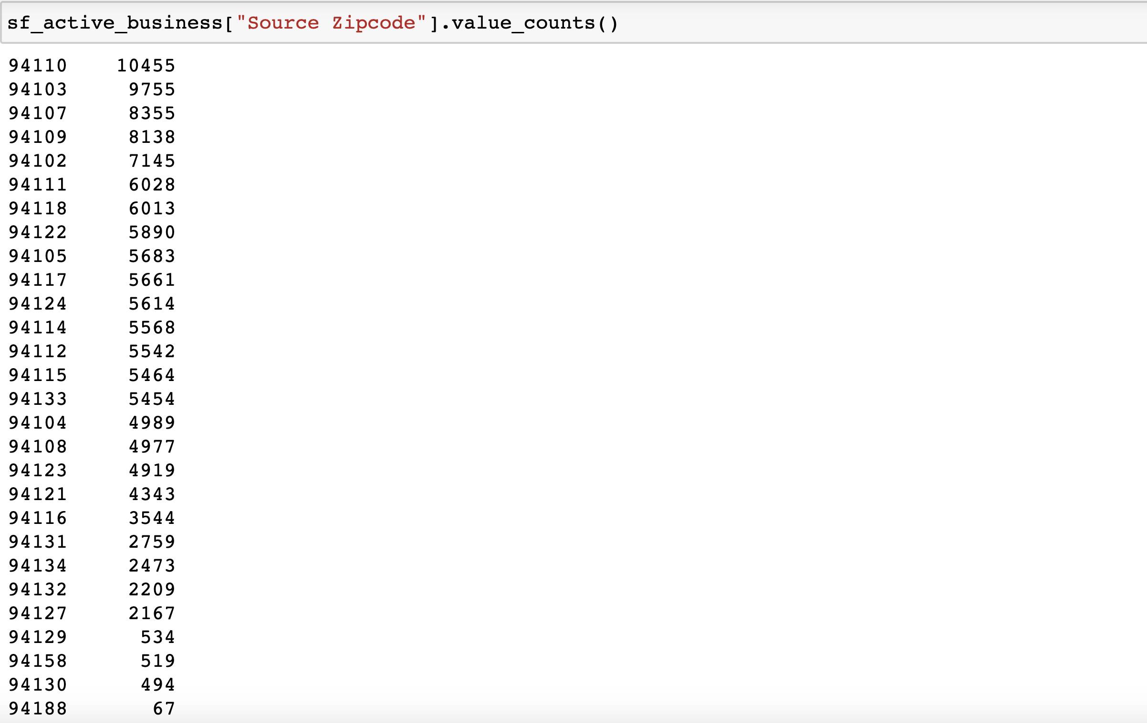

Visualizing the Number of Businesses concerning the zip codes.

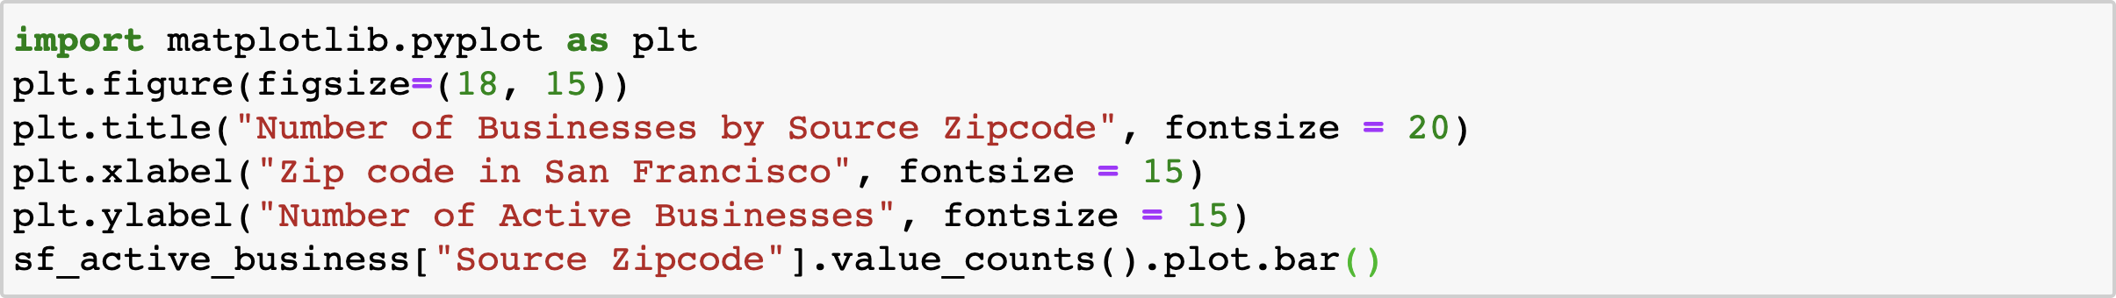

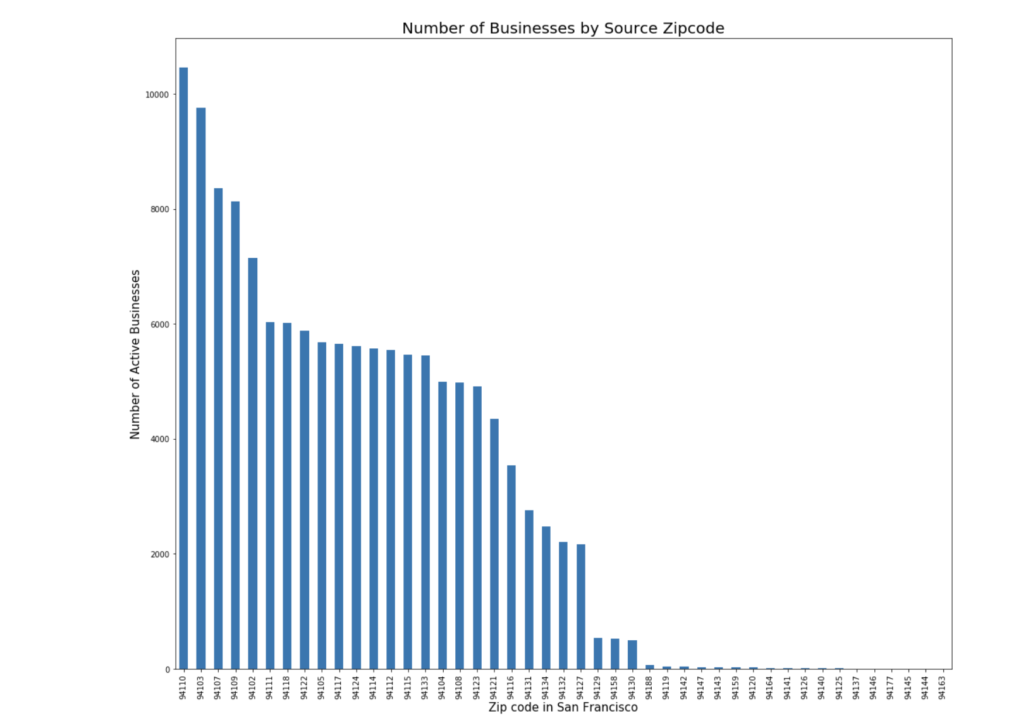

**Interpretation:** The bar plot shows the number of active businesses as per Zip Codes. So, we can determine the top 5 Zip codes of San Francisco with the highest number of businesses is as follows:

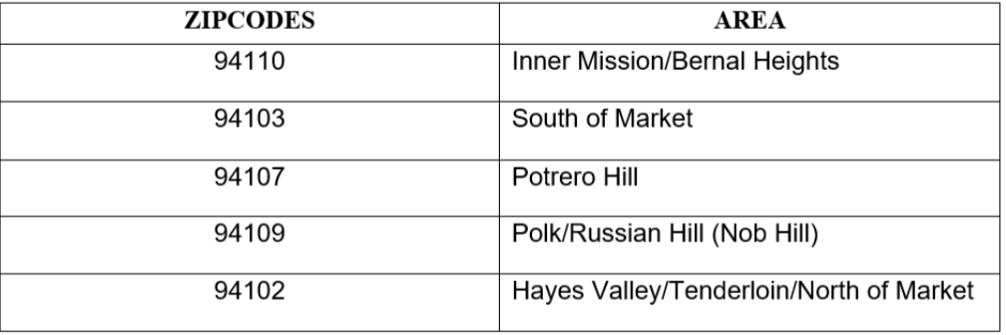

We have used a **library Folium which is a powerful data visualization library in Python to visualize Geographic data.** With Folium, we created a map of San Francisco whose latitude and longitude values are known.

Created a base map, simply by-passing latitude and longitude coordinates to Folium

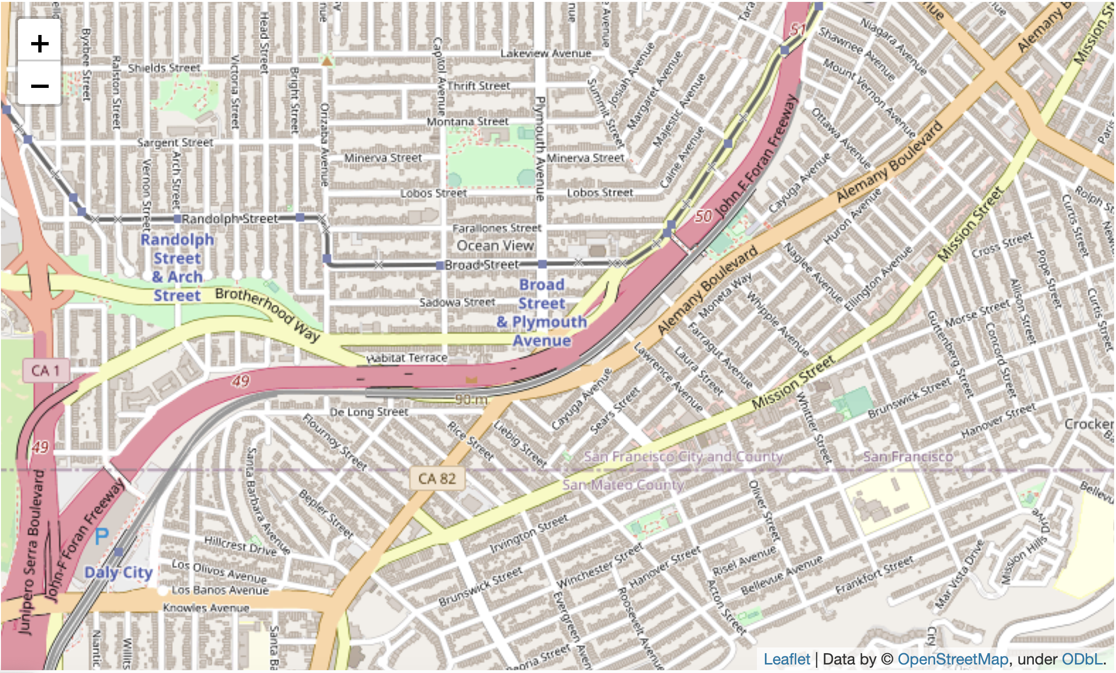

The presence of businesses across different regions of San Francisco is depicted by below map

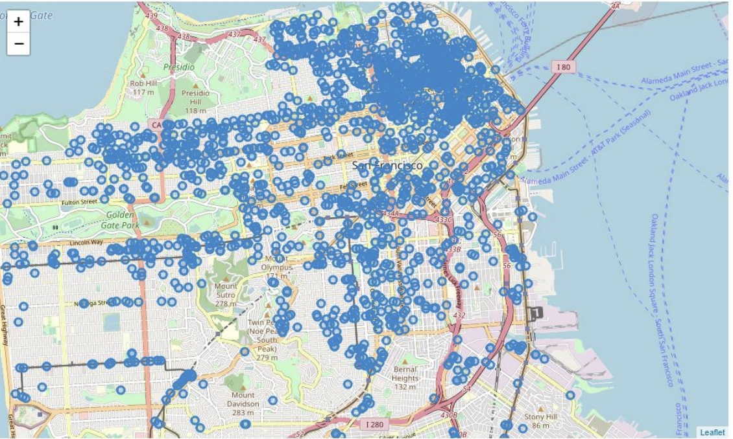

**Interpretation:** This gives us a brief look into the grouping of business areas over the city with which we can limit down the areas of higher business numbers. Accordingly, one can accumulate the facts regarding why a lot of businesses have set up workplaces in a particular region and the surrounding components around it to decide if to begin a business in those areas itself for higher accessibility or a different faraway area to suppress competition.

Another way of analyzing the businesses is to know the number of null values and the number of businesses in each industry. In this way, we can decide which industry requires more focus and how can the resources be made available to them to prosper. Below is the table that renders the above:

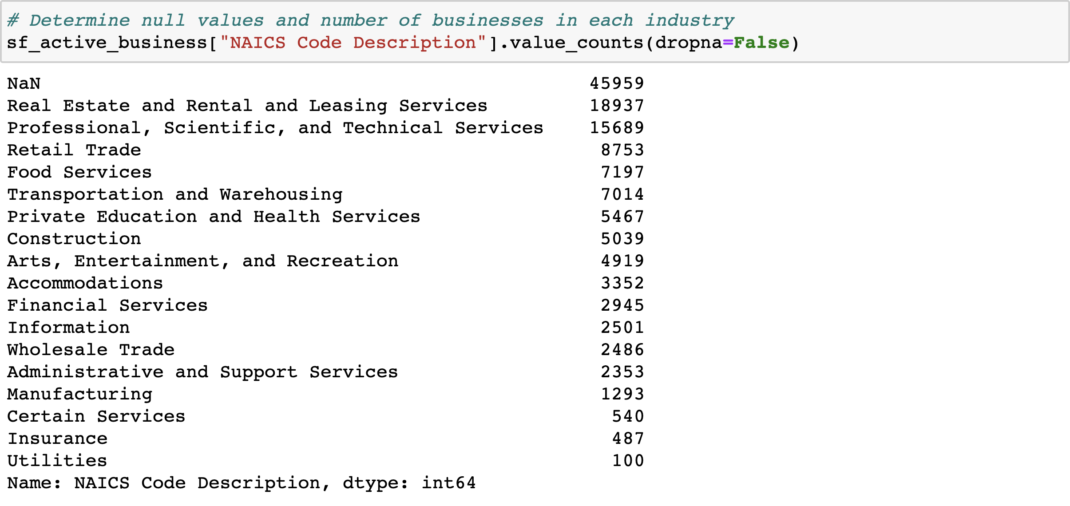

As we can see, we get a significantly high number of null values. To know more about these null values, we got interested in knowing the number of null values in each attribute. What we obtained is depicted below:

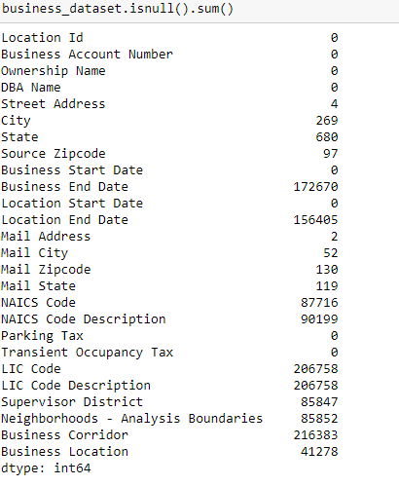

As we didn’t want to lose any useful data and at the same time eliminate the null values of the column of least significance, we decided to know the null values considering both the NAICS Code and Description columns. The number of null values dropped significantly. Hence, we go ahead to plot a bar graph for analyzing the strength of industries based on the number of businesses.

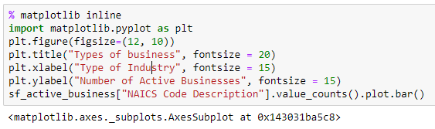

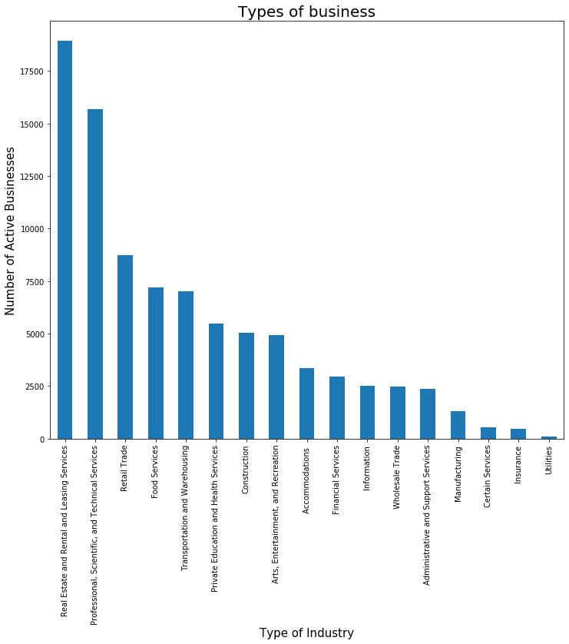

**Interpretation:** We can conclude that Utilities, Insurance, Certain Services, Manufacturing are the least popular industry categories in which businesses have come up. Before eliminating the consideration of these industries, it is good to confirm the number of businesses in less popular industries as compared to the total number of active businesses in San Francisco. If the number is relatively less, we can go ahead in not considering them.

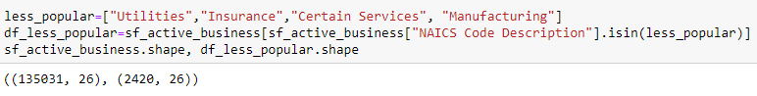

Since the number of businesses in less popular industries is not significant, we will focus on finding the number of active businesses in each category. This can also be checked by obtaining the NAICS Code and Description of industries having the least count of business.

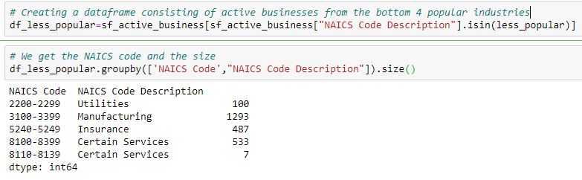

Having known the above, it is better to pivot on the industry categories which have been lagging in recent years. That way, we can focus resources on nourishing businesses in those categories. We consider the recent 6 years to head towards bringing those industries into the competitive market which have fallen behind in the age of technology. Out of the number of businesses in the above table for each category, only the numbers shown in the below screenshot renders the active business in each category after the year 2012. The motive behind this is to know the latest scenario in each category. Had all the numbers been in the upper 70% of the total, we would have considered these categories.

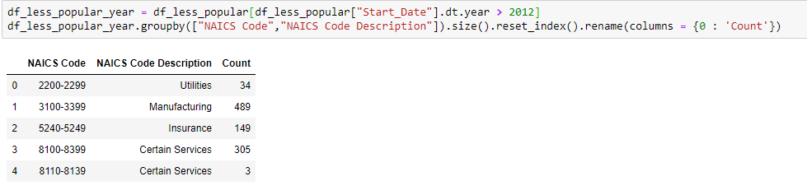

* ***Analysis:*** Since these were first categorized, we can conclude that the *Utilities, Insurance, Certain Services, Manufacturing* industries are still lagging in the modern age. The government needs to nucleus its attention and funding into improving businesses in these sectors
* It is observed that insurance plans don’t include a wide portion of the healthcare industry. Improving the insurance plans will lead people to buy more affordable and cost-friendly healthcare plans which would, in turn, result in higher revenues for the industry
* Customer satisfaction plays a vital role in any business’s success. Strategizing plans to improve customer’s satisfaction by increasing the quality of goods rather than quantity, cost-effective options, better customer service plans, etc would lead to more competition in the market resulting in gradual growth and achieving the goal of high customer satisfaction
* The business activity that NAICS code maps on to (it can be multiple if there are multiple codes indicated for the business). As we grouped the NAICS Code and Description, it segregated or grouped the "Certain Services" basis on different NAICS codes in the dataset. As the NAICS Code for two "Certain Services" are different, we can see two "Certain Services" in the result

After deciding to not consider the above categories, we need to delve deeper into businesses that have emerged in San Francisco over the years. For achieving this, we will first apply the filter to fetch businesses in San Francisco by joining it with the Zip Codes file.

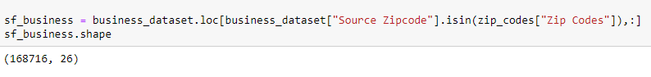

To achieve the objective, we get the business start date and find out the most last and the most recent year in which businesses have sprung up. We can check industry-wise the starting year and ending year along with the count of businesses industry-wise to determine the popularity based on the number of businesses.

Firstly, we calculate the numbers of businesses starting each year listed in the dataset.



**A snippet of the output is as follows:**

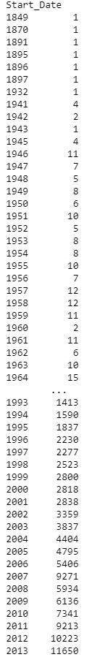

Below listed are the count of total businesses according to each category along with the starting year and ending/current year of each business.

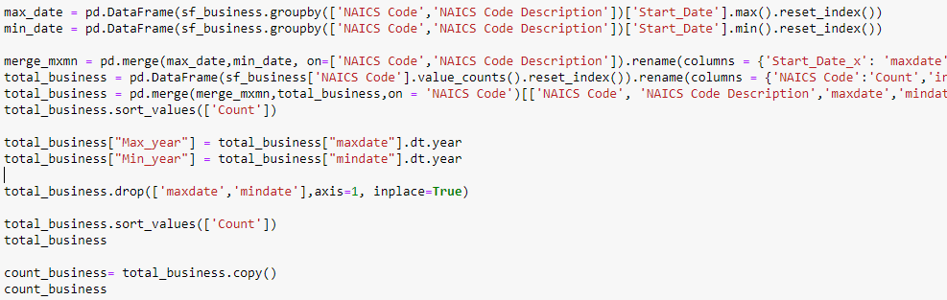

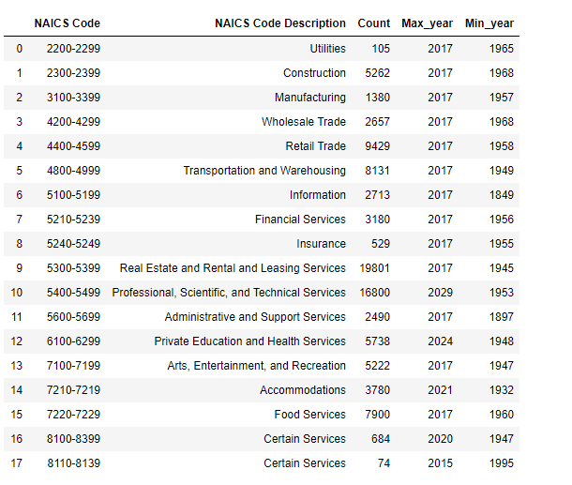

Below listed are the count of active businesses according to each category along with the starting year and ending/current year of each business.

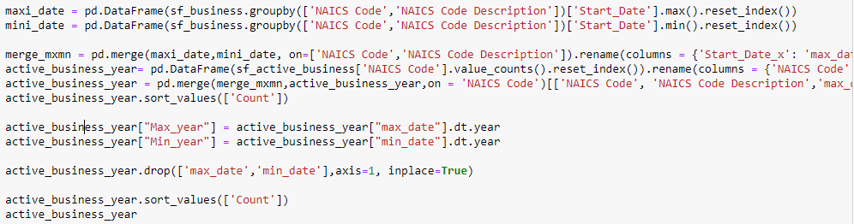

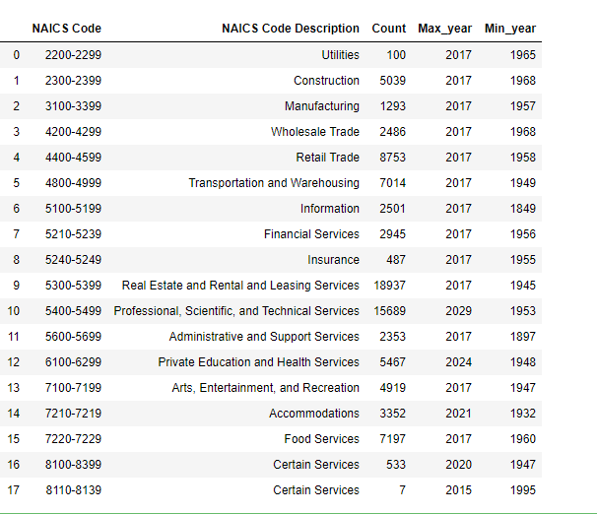

* ***Analysis:*** The reason for studying active businesses is because they are the most contributors to the revenue and economy of the country
* Before 1950, we can see that businesses in the field of *Information, Administrative and Support Services, Transportation and Warehousing* were flourishing
* After the 1950 decade, industries such as *Real Estate and Rental and Leasing Services, Professional, Scientific, and Technical Services along with Wholesale* trade came to light

To check the status or period of activeness of business, we decided to generate a ratio of determining the number of businesses that have remained active throughout the years since the genesis of the industry by dividing the count of active businesses to that of total businesses in San Francisco.

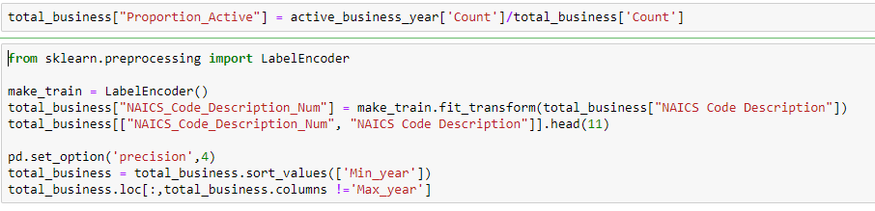

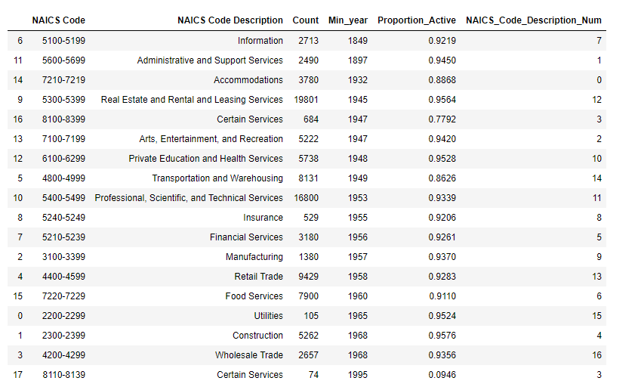

***Why only 0.9 as cut-off value?***

The reason for choosing 0.9 as the cut-off value is because most of the businesses had value near to 0.9. We held 0.9 as the threshold to compare the activeness of other businesses and hence eliminated those which had a value less than 0.9. It is as good as selecting different p-values as a test of significance.

Different levels of cut-off trade-off countervailing effects. For example: Lower levels – such as 0.01 instead of 0.05 – are stricter, and increase confidence in the determination of significance, but run an increased risk of failing to reject a false null hypothesis.

Similarly, we could have chosen any other value than 0.9 but that would pose stricter regulation on our analysis and result in eliminating more businesses.

* ***Analysis:*** As observed from the above table, we can conclude that *Certain Services* indexed at 17 have seen no growth in business as there was no addition of new business that came up in recent years. This can be ceased by the ratio of activeness remarkably close to zero (~0.1) or less than 0.9.
* In addition to Certain Services, other industries such as *Accommodations, Transportation, and Warehousing* industries have also seen less emergence over the years (with a ratio of less than 0.9)
* Alternatively, the rest of the industries have an active proportion of emerging businesses since their ratio is above 0.9
* ***Solution:*** There are two types of taxes posed on the businesses in this dataset: **Parking tax and Transient Occupancy tax**. After separating businesses having a ratio of less than 0.9, it was noticed that they had to give either of the taxes even though they were not as flourished as others. Hence, we thought exempting them from the tax would be a considerable solution in helping them save more money that they can invest in growing their business and making enough profits to get into a good proportion of active businesses in their industry.

In our suggestion, the industries with a ratio of **less than 0.90** could benefit if awarded a choice of the tax break to generate more revenue and expand their business to increase profits. Alternatively, other industries that have a proportion of emerging businesses **greater than or equal to 0.9** must be exempted from the tax break scheme. They should not be any relaxation in tax as they are already doing well in their businesses

**Prediction Model using Machine Learning**

Moving forward, we aim to find the best business concerning the industry to start or invest. Decision Trees (DTs) are probably one of the most useful supervised learning algorithms out there. As opposed to unsupervised learning (where there is no output variable to guide the learning process and data is explored by algorithms to find patterns), in supervised learning your existing data is already labelled and you know which behaviour you want to predict in the new data you obtain.

DTs are ML algorithms that progressively divide data sets into smaller data groups based on a descriptive feature until they reach sets that are small enough to be described by some label.

We used decision tree modelling on the filtered dataset to predict the best industries to invest in for future references. In our case the decision tree is giving us the types of businesses as an outcome. These businesses are safe to invest in currently.

The first step in any model building is to split the dataset into training and test data. We would do the same by importing the required packages.

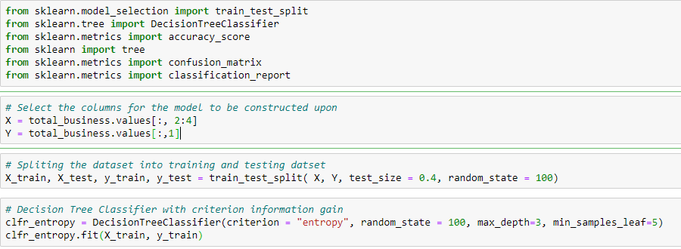

**Output:**

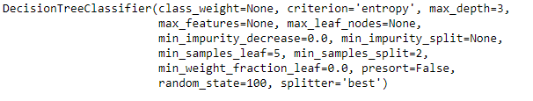

**Prediction for DT classifier:**

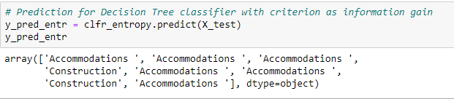

**Confusion Matrix:**

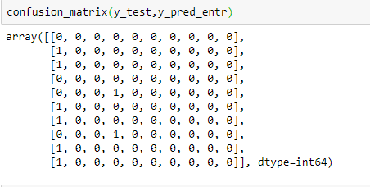

**To graphically visualize the decision tree modelled on the above prediction, we need to import some packages which are as follows:**

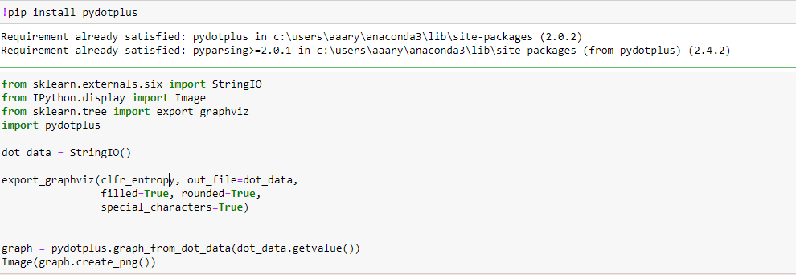

**Output:**

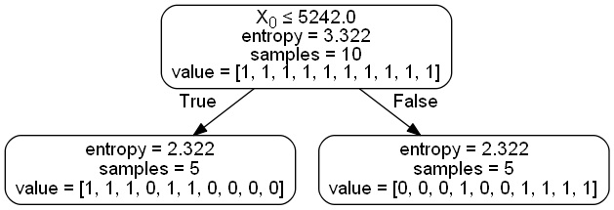

***As per our model Accommodation and Construction are two business categories safe to invest in.***

Having known the best business to invest in, we can route our analysis to know more about the relationship between the effect of the number of businesses in the success of that particular industry. In other words, the basis of the formulation of our hypothesis. The first step towards this would be to compare and contrast between the Total Businesses versus Active Businesses.

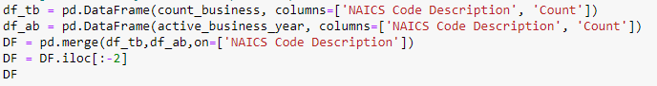

**Output:**

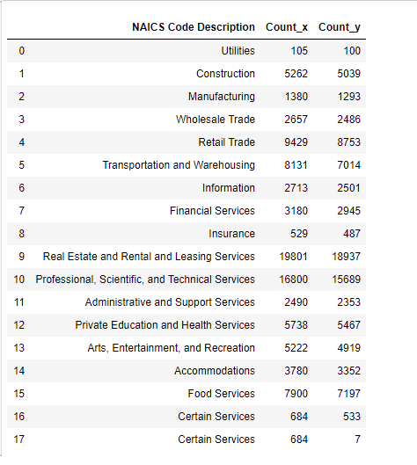

To make it better comprehensible, we remove the numbered index and set the business category as the index. The transformed table would look as follows:

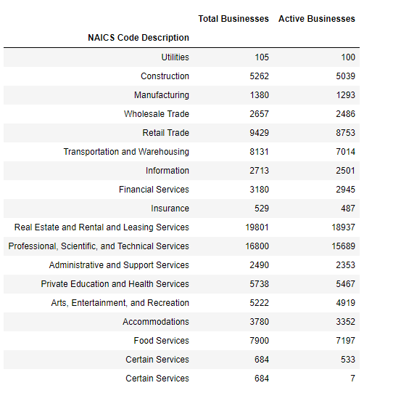

**Visualization of the above table would look as follows:**



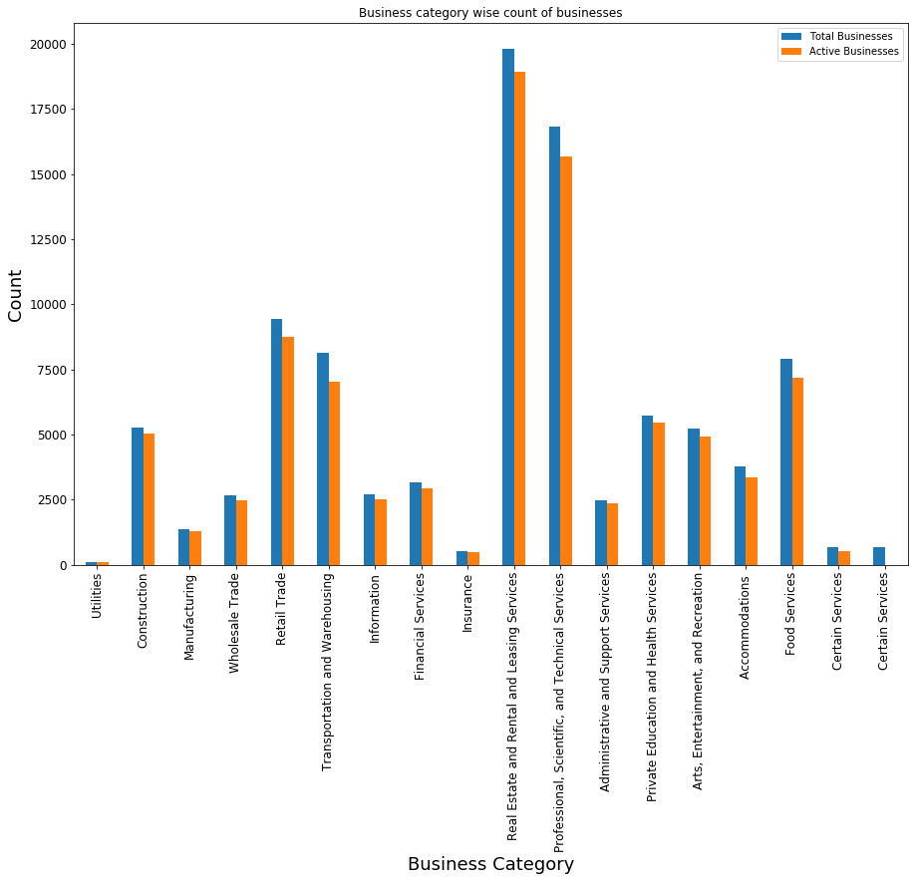

**Hypothesis Explanation**

In recent years we've seen tremendous growth in the industries. These industries come from various markets and have since flourished. In general, one result of a company is one out of two, either it prospers or it fails. We developed our assumption around this theory.

Our visualization and proportion of business have helped us decide to reject the alternate hypothesis and accepting the null hypothesis. It is clear that the greater the number of businesses introduced in each category, the more the competition amongst them resulting in favoritism and eventually decreasing the number of active businesses in that category.

**CONCLUSION**

We performed various investigations along different lines to analyze the nature of the business, the impact of introducing new businesses in the same category, plotting them on a map, to name a few. The findings are summarized below:

* With the use of folium library, we visualized our data and explored questions such as which pockets of San Francisco have the highest number of active businesses
* With the help of data analysis techniques, we calculated which companies will benefit from the tax break scheme and show steady growth
* With the help of the panda's library, we tried to evaluate the market trend over the years, which market categories were popular, and which categories did not see growth or new businesses emerging over a long period
* The conclusion drawn from these analyzes helped us understand the corporate patterns and their needs along with their location preferences for optimal performance. Finally, when we came to the project's main focus, we developed a hypothesis to deduce whether more businesses in each category will result in higher competition resulting in a decrease in business or rather create a demand of similar services increasing businesses
* Our visualization and business ratio have helped us decide to dismiss the alternative hypothesis and accept the null hypothesis. It is clear that the larger the number of enterprises introduced in each category, the more the competition among them will result in favoritism and eventually the number of active enterprises in that category will decrease

**REFERENCES**

1. <https://towardsdatascience.com/the-complete-guide-to-decision-trees-28a4e3c7be14>
2. <https://www.kdnuggets.com/2018/09/visualising-geospatial-data-python-folium.html>
3. <https://pythonprogramminglanguage.com/decision-tree-visual-example/>
4. <https://www.w3schools.com/python/python_regex.asp>
5. <https://pythonspot.com/matplotlib-bar-chart/>
6. <https://python-graph-gallery.com/barplot/>
7. <https://www.geeksforgeeks.org/python-pandas-dataframe/>